**Assignment – 3**

* • **Use the Employee Details dataset and perform the following activities: -**

− *Split the column CITY and separate the code associate with each city like - Allahabad[AL2] should be only Allahabad and [A2] will be separate.*

− Extract the first name from EMPLOYEE NAME column and transform the column.

− *Using the JOINING DATE column extract the Year and no. of days for that month .*

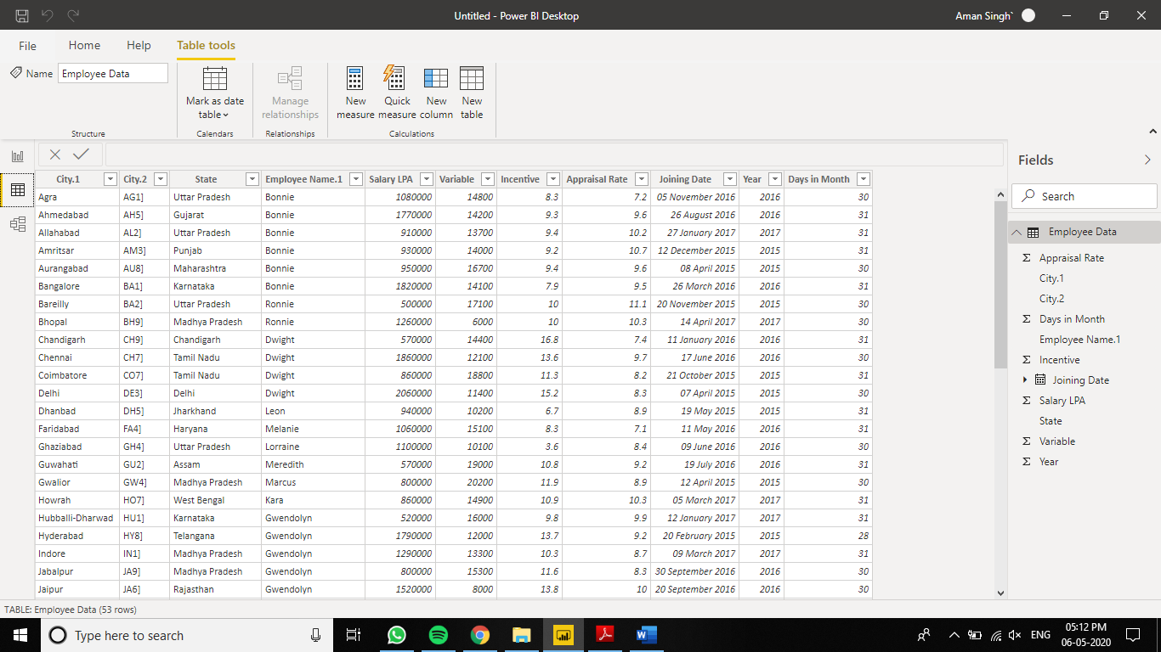

− *Create a visual of your choice and show the how much salary has been paid to each state and which state has lowest payout.*

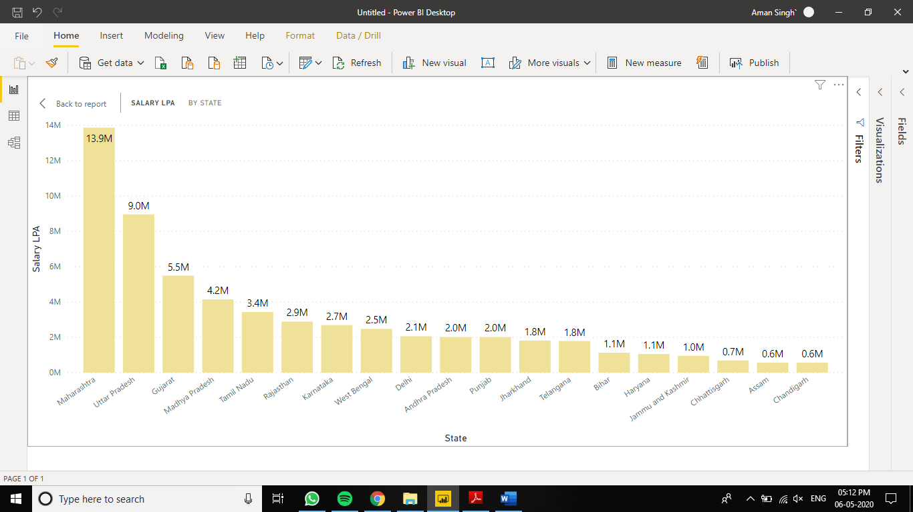

Ans :- As You can see the lowest salary has been given to Chandigarh – 0.6 M